**Assignment 3**

1. Create an informed mutation operator and compare the results with those from last time.
2. Write a short text about what you tried, how it worked and submit a plot showing the difference.

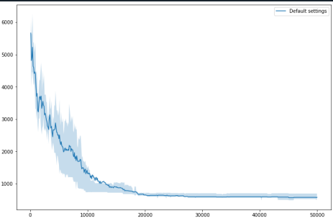

Fig: Output without any alteration in the code.

1. Modifying the crossover operator to uniform crossover without altering rest of code.

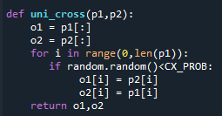

With Crossover probability of 90%.

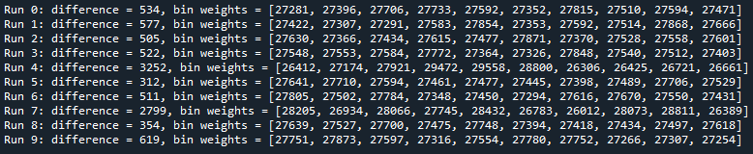

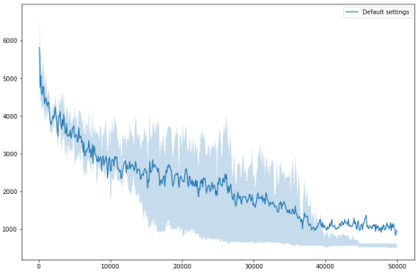

With Crossover probability of 95%.

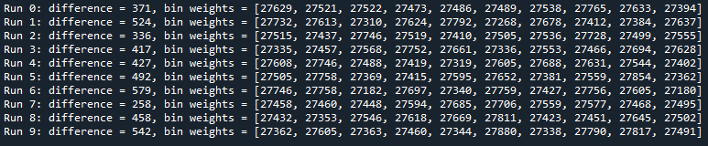

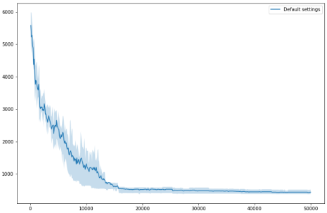

After multiple runs, the least difference value obtained with uniform crossover was 163 with Crossover probability at 97%.

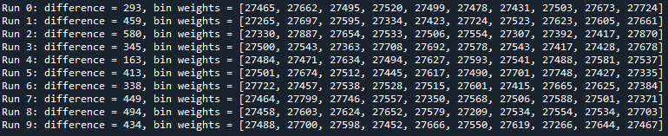

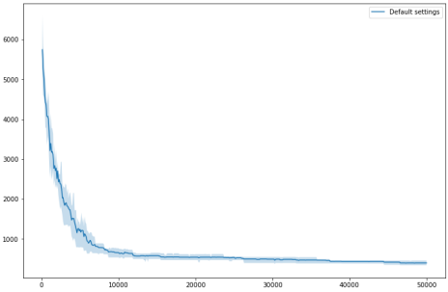

1. Modifying the crossover operator to two point crossover without altering rest of code.

With Crossover probability of 90%.

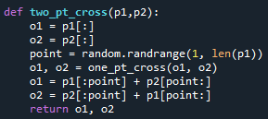

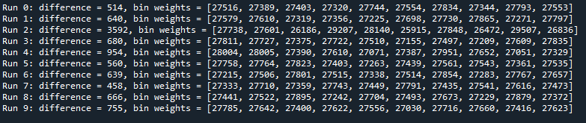

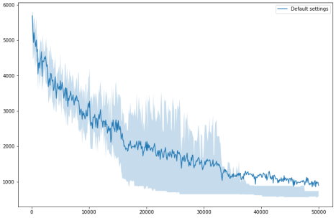

After multiple runs, the least difference value obtained with uniform crossover was 409 with Crossover probability at 90%.

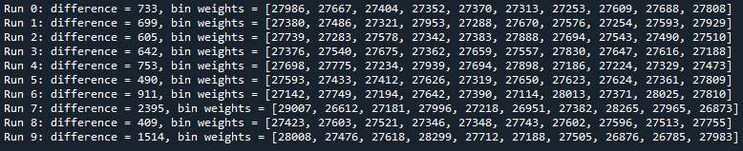

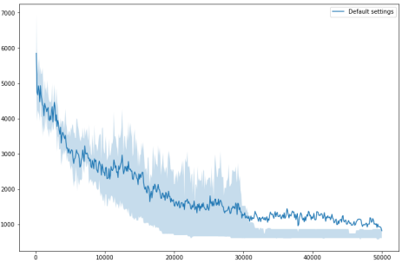

With Crossover probability of 80%.

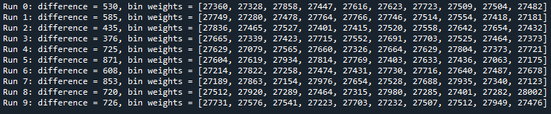

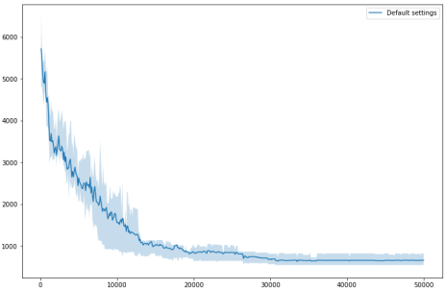

After multiple runs, the least difference value obtained with uniform crossover was 409 with Crossover probability at 80%.

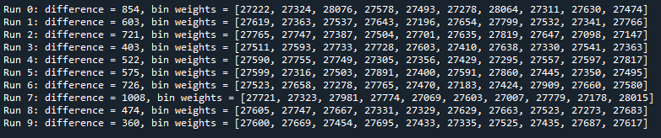

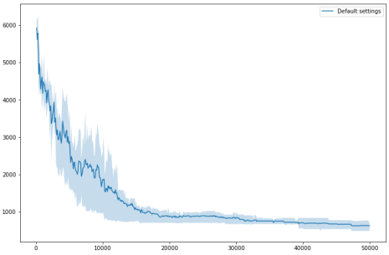

1. Mutation, which swaps parts of the encoding inside the individual.

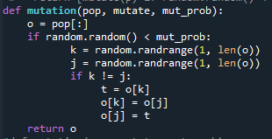

With one_pt_cross & mutation prob at 20%.

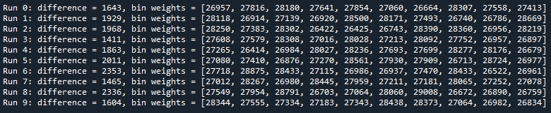

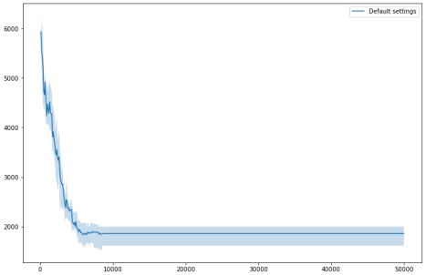

With Uniform_crossover & mutation prob at 20%.

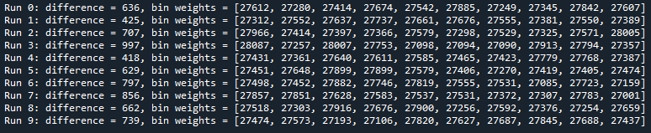

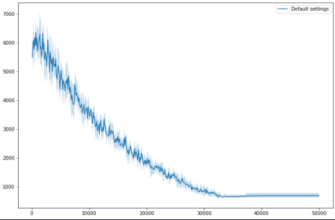

After multiple runs, the least difference value obtained with uniform crossover was 298 with Crossover probability at 80% & Mutation probability at 20%.

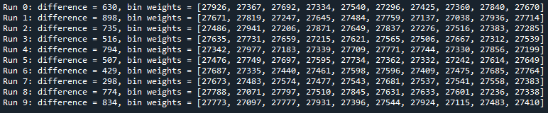

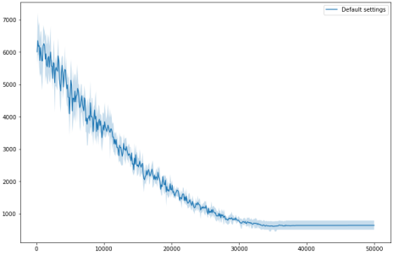

With Uniform_crossover & mutation prob at 20%.

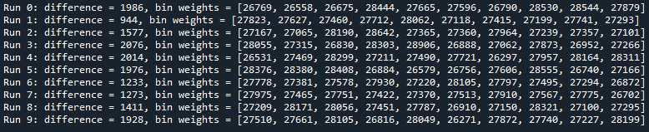

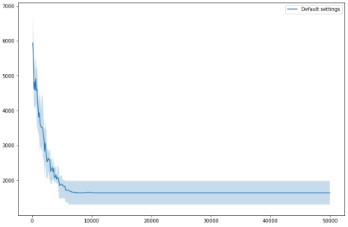

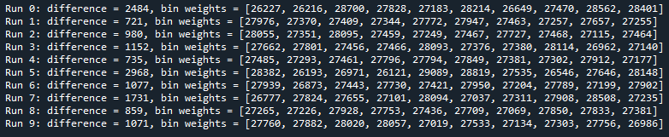

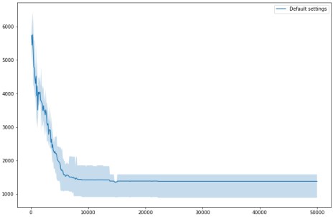

After multiple runs, the least difference value obtained with uniform crossover was 553 with Crossover probability at 95% & Mutation probability at 50%.

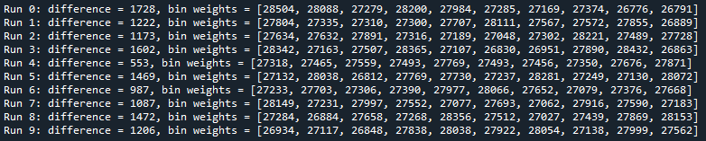

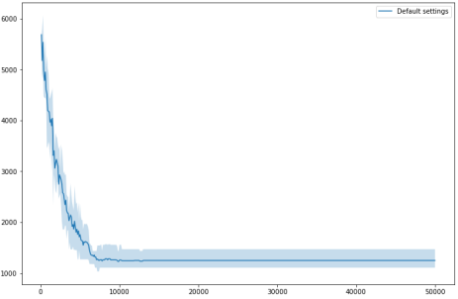

1. Modifying bin weights by swapping an individual between them.

Code:

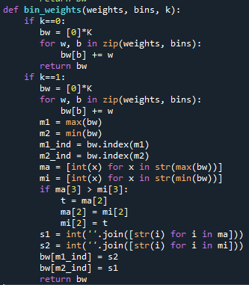

Fig: The code modified for bin weights(makes direct changes).

With Uniform Crossover probability -> 80% & Mutation(modified code from (c)) probability -> 20%.

